**Java Web Application Build Documentation**

**Step-by-Step Process**

**1. System Update**

**sudo apt update -y**

**2. Java Verification**

**java --version**

**Output:**

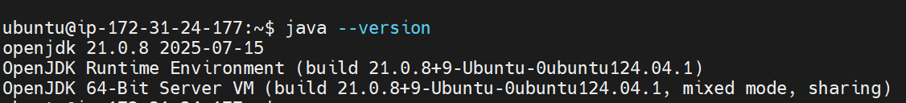

**3. Maven Installation**

sudo apt install maven

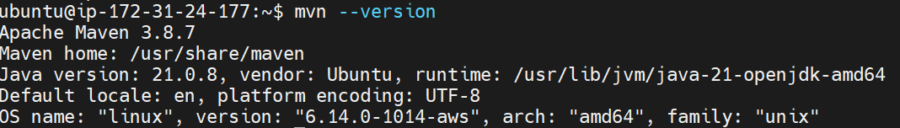

**4. Clone the code from GitHub**

git clone https://github.com/akracad/JavaWebCal.git

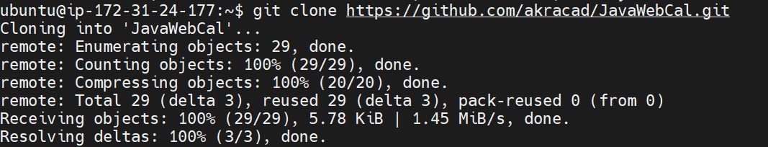

**5.List the files with the command ls**



**6. Change the directory JavaWebCal**

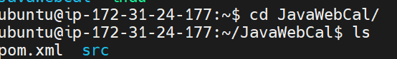

**7.Build the artifact by using the command mvn package**

**Output:**

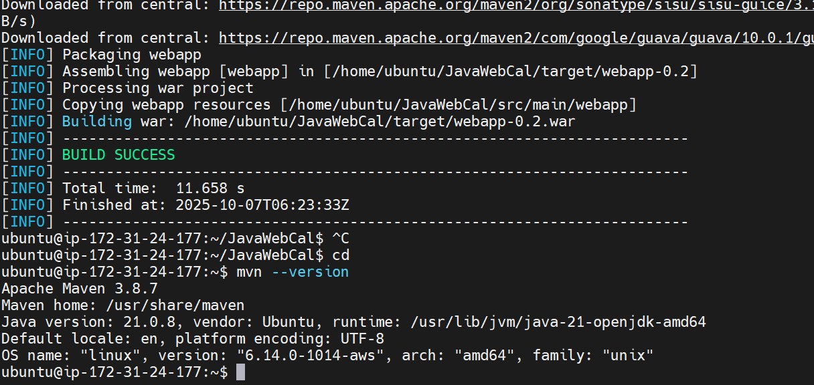

**After build success we will get target folder now go to target folder.**

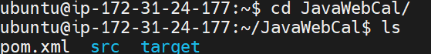

**Now go to target folder we will get .war file**



**Now go to another server and install java and apache tomcat in that server.**

**1. System Update**

**sudo apt update -y**

**2. Java Verification**

**java --version**

**Output:**



**3. Now install Apache Tomcat**

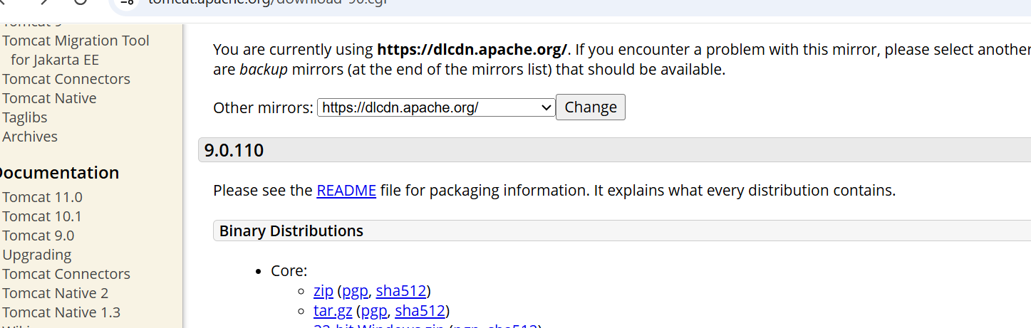

**Now go to terminal and paste the tomcat url by using the command wget.**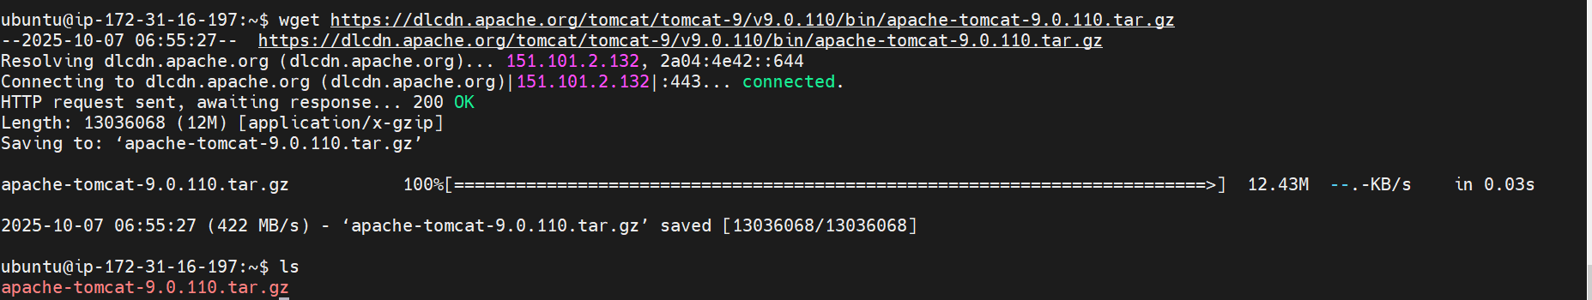

**Next Extract the apache-tomcat by usin the command tar -xvf apache-tomcat-9.0.110.tar.gz.**

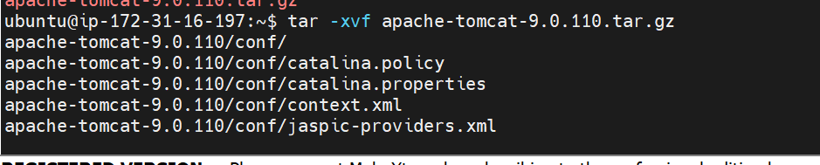

Next go to the blue colour folder(extracted folder) with command cd.

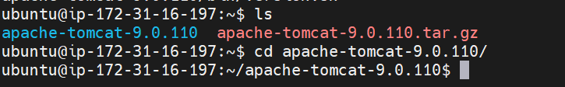

Now start the tomcat server

1. Go to bin folder
2. Ls
3. With ./startup.sh command start the server

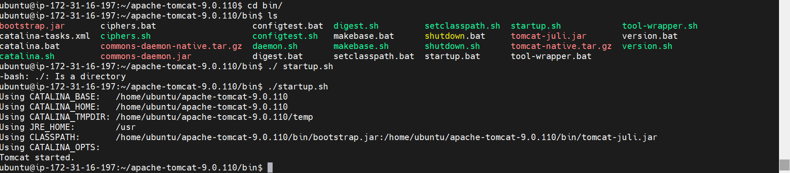

See, the tomcat server is running now.

Now we have to edit security of that server instance in aws,

Instance

|

Security

|

Security groups

|

Edit inbound rules

|

Add rule

|

Port number 8080

|

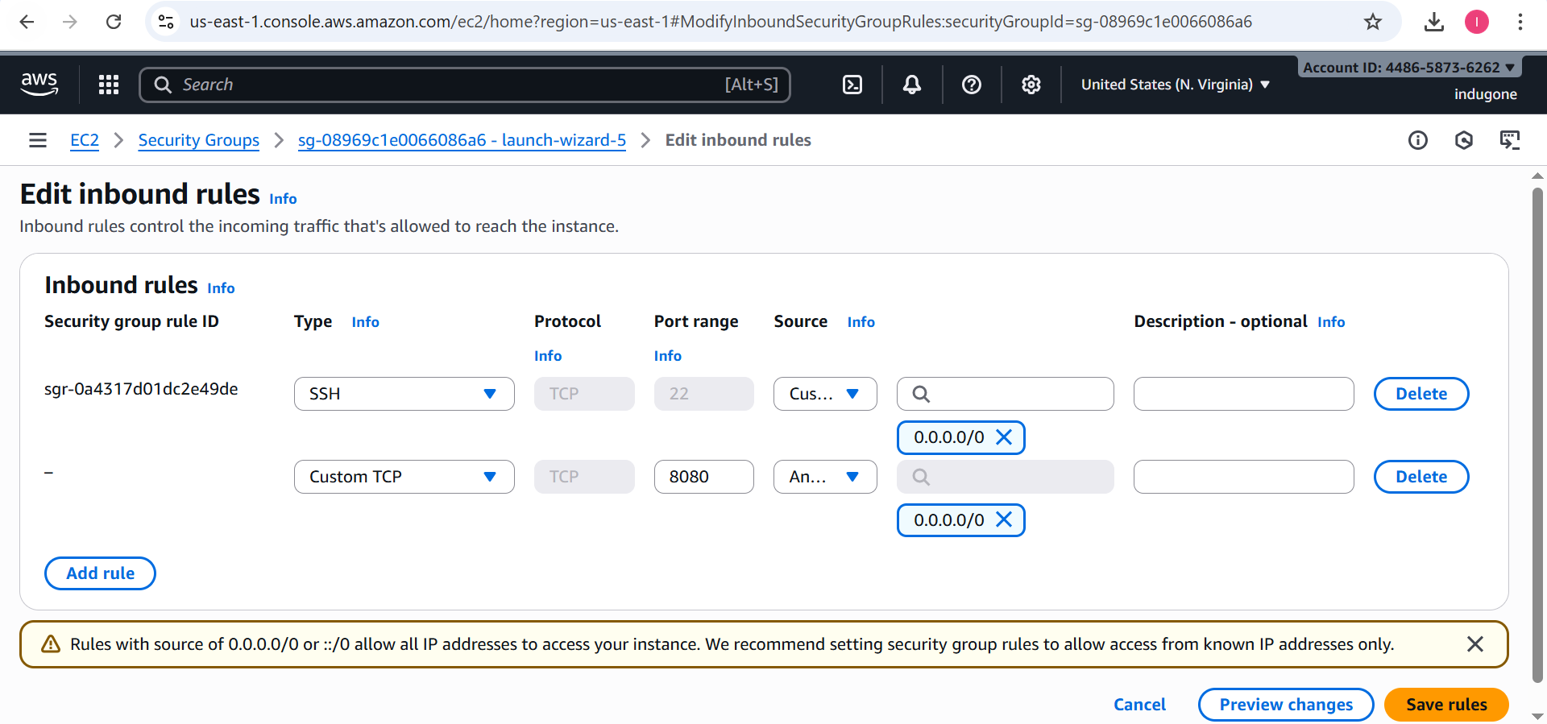

Now click on save rules, take the apache tomcat server public ip address then go to browser and check weather the server is running or not.

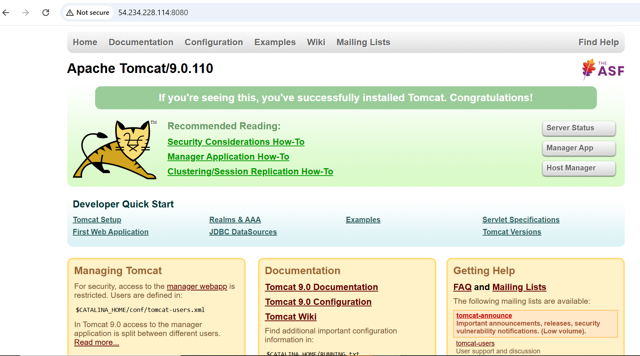

Next click on manager app, we will get error

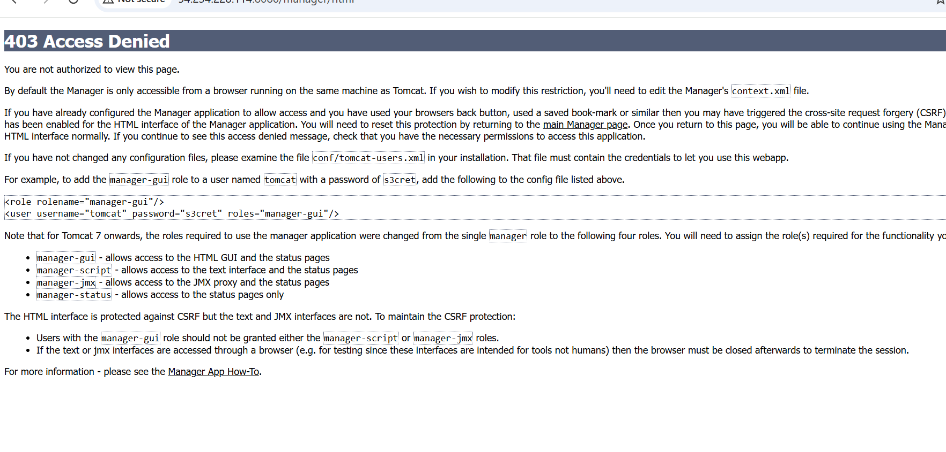

For these error we have to modify some changes in apache instance, got to webapps in webapps go manager in manager go to META-INF in META -INF edit vi context.xml file

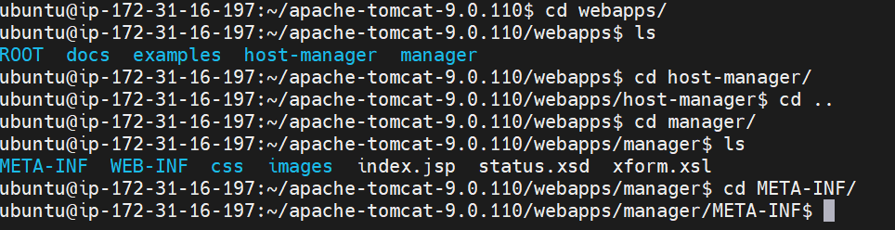



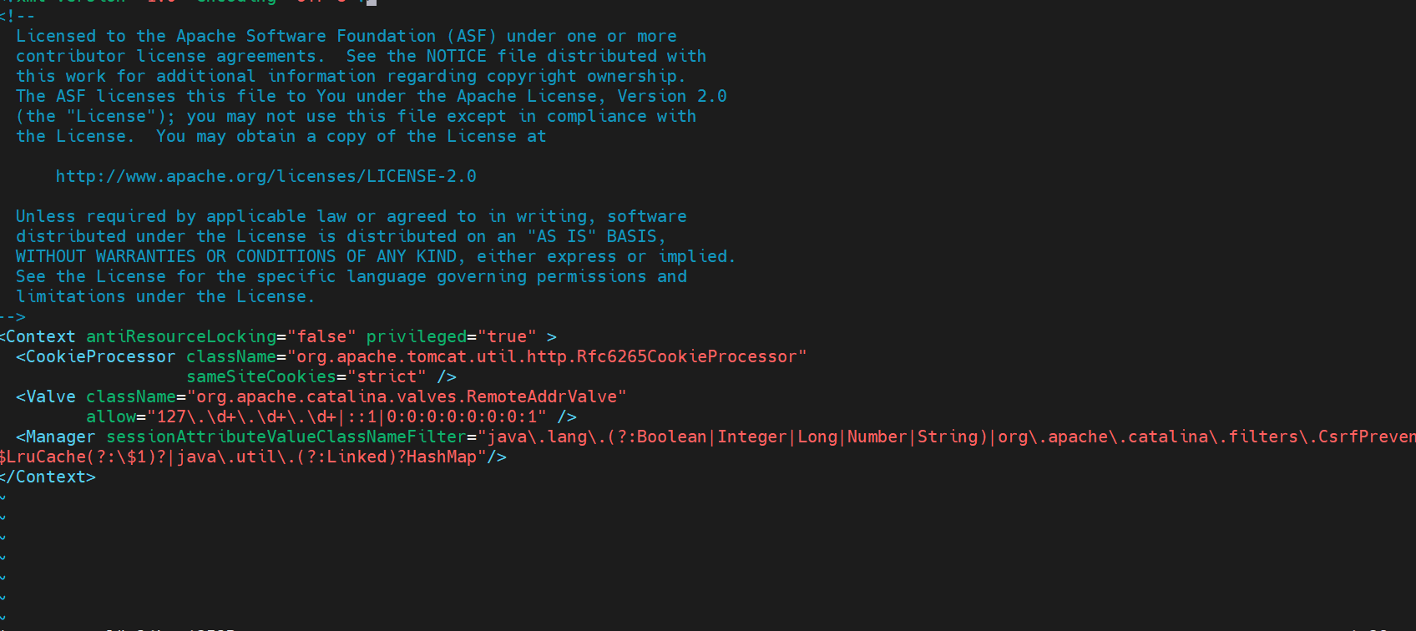



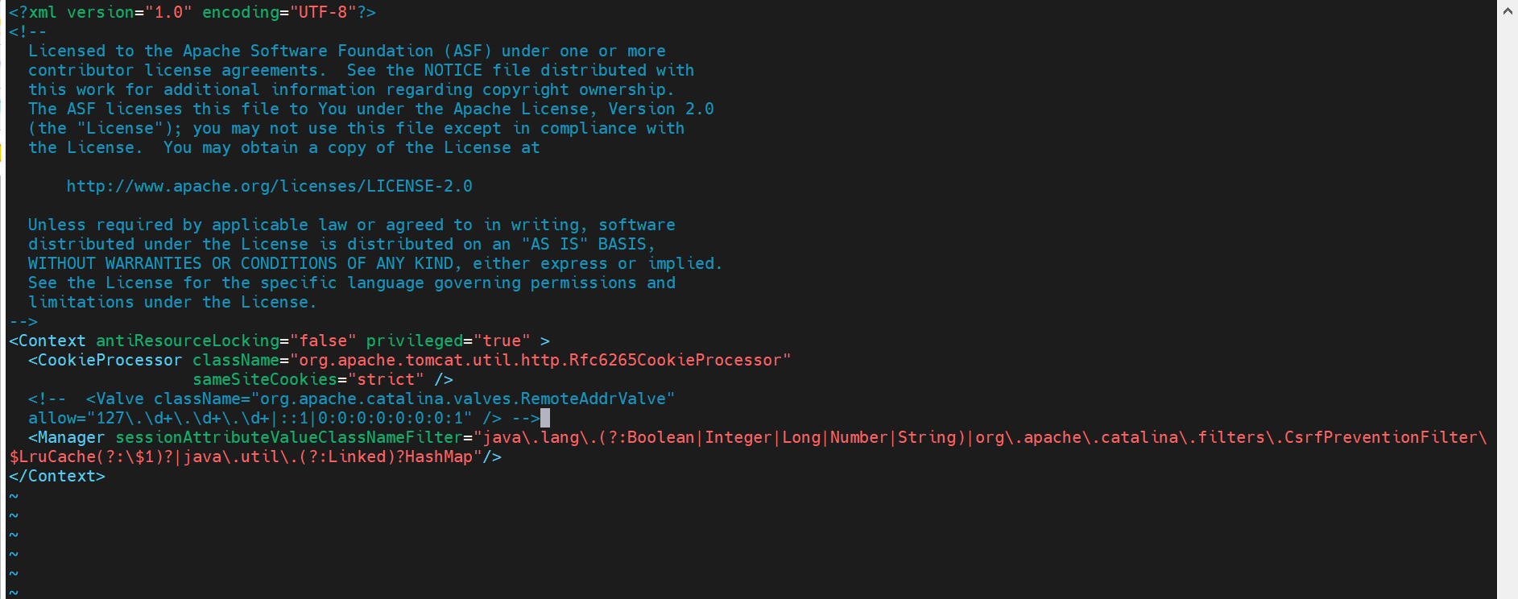



Next got host-manager in that go to META – INF go to context.xml and edit the file.

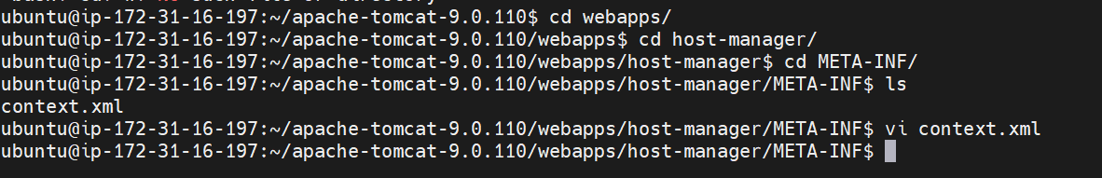





no



Now go to browser and refresh it, it will ask the user name and password 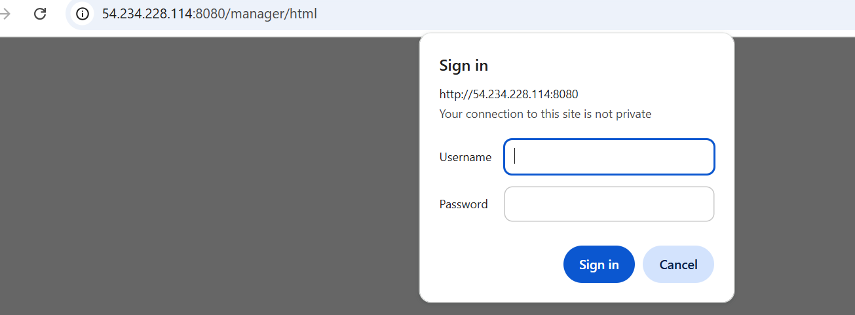



we have to edit the tomcat-users.xml to give the username and password go to conf in conf go to tomcat-users.xml and edit this

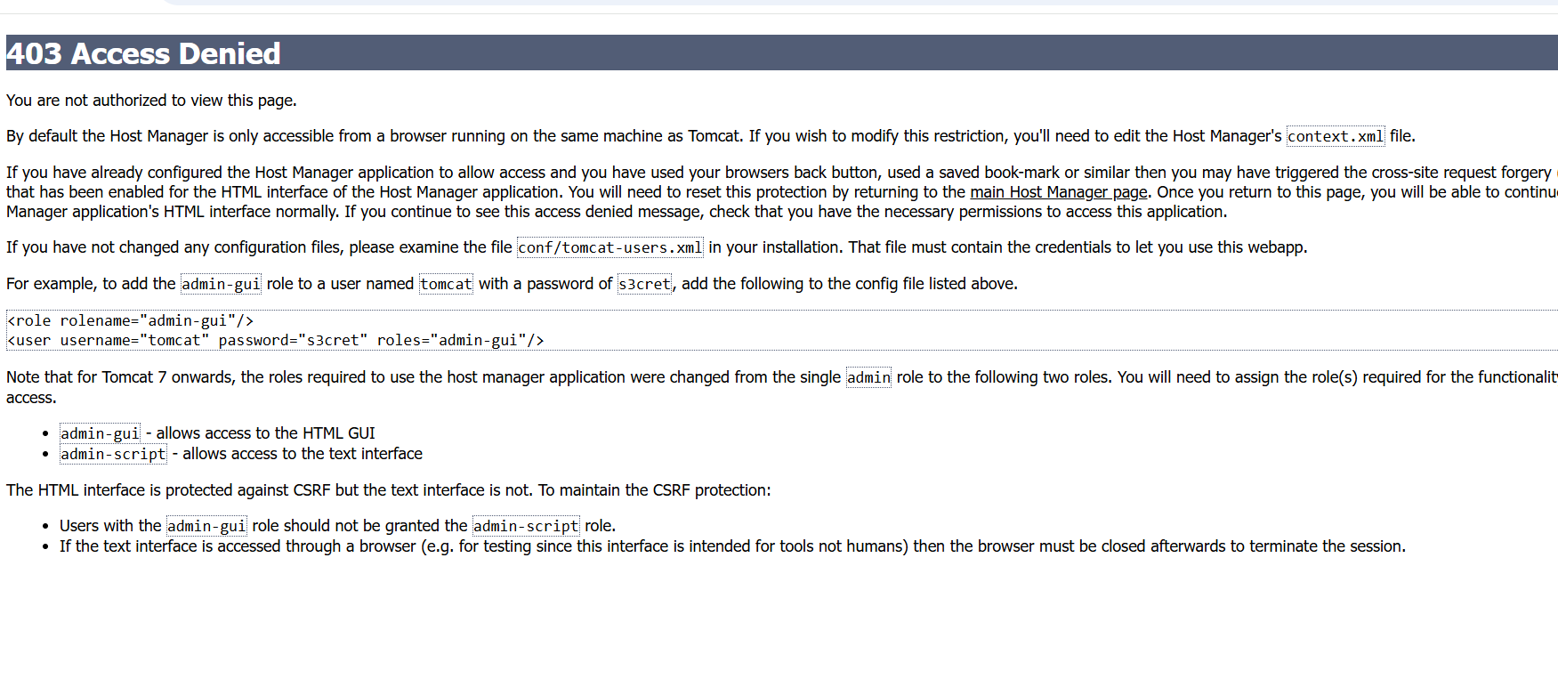



Take the above mark line and paste it in the tomcat-user.xml

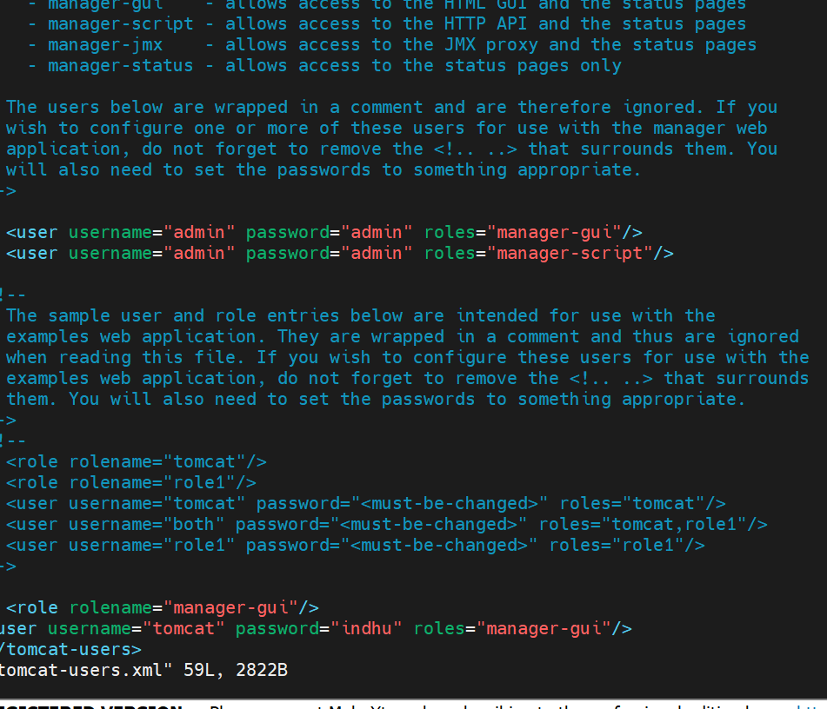



Next to browser mangaer app and type the username and password

Output:

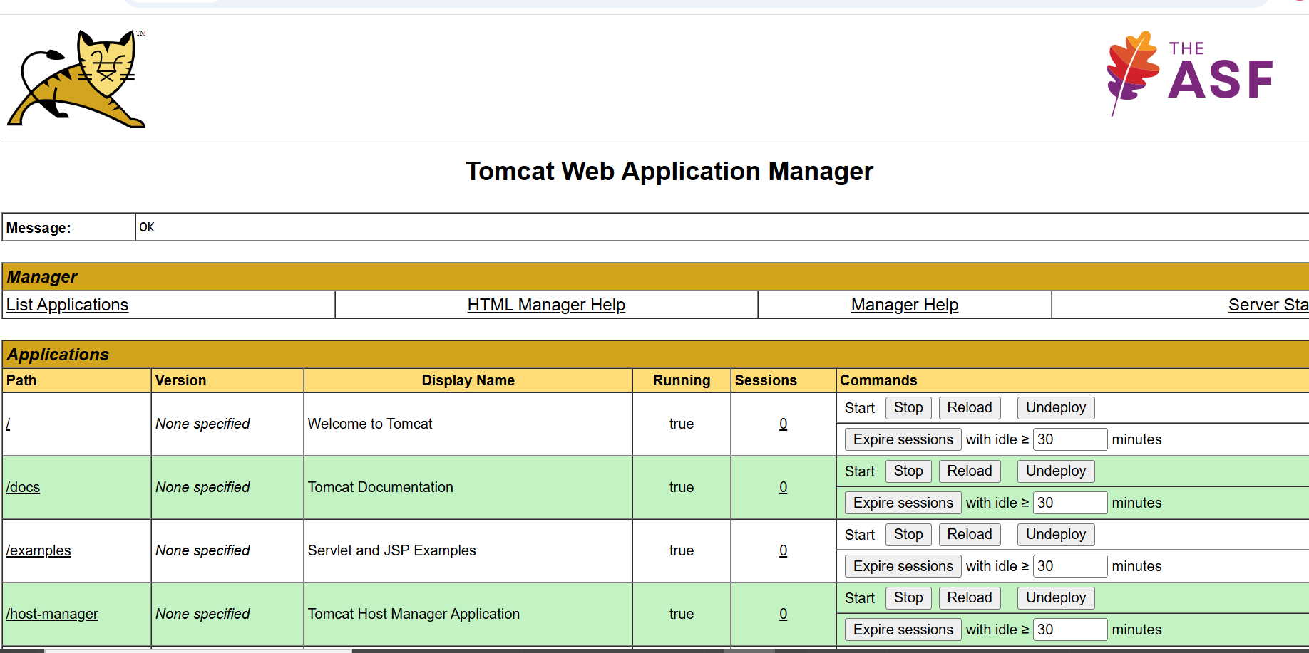

Now go to build server and generate ssh keys in build server.

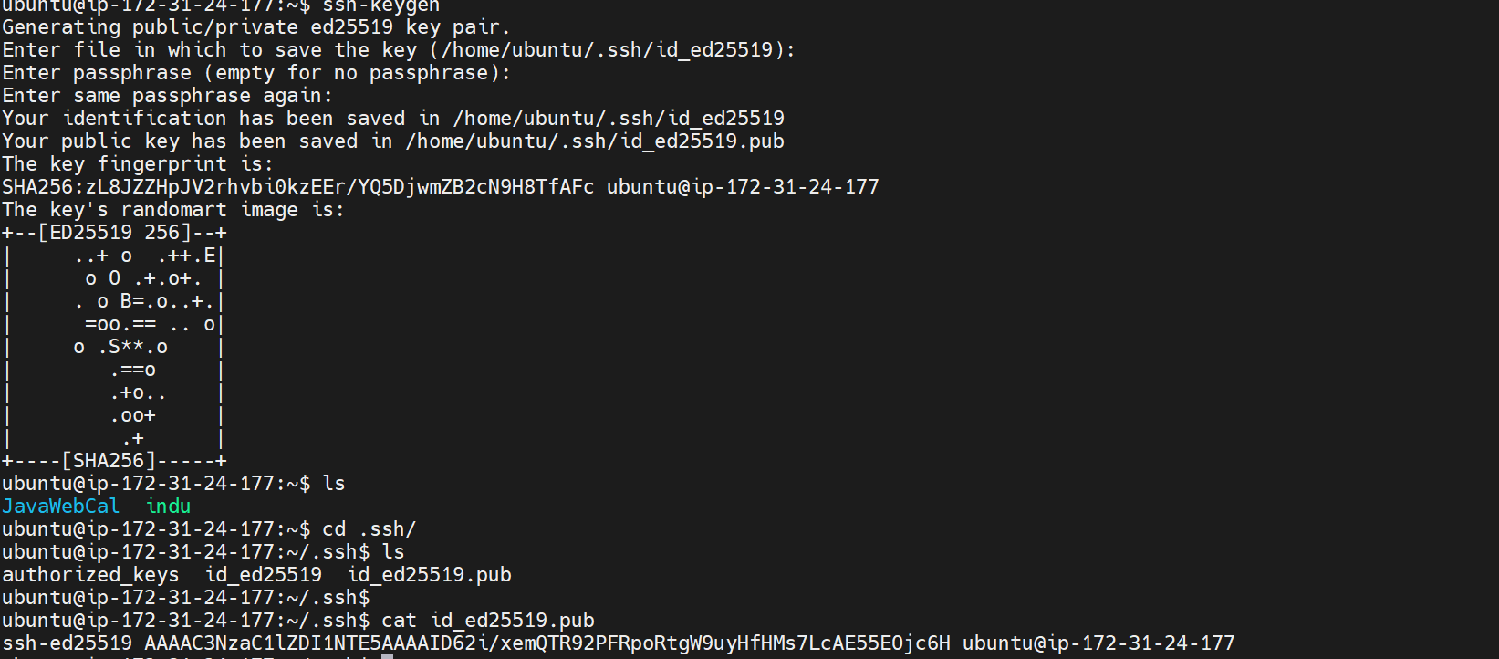

Now take the public key and paste it in apache server. Go to cd ..ssh in that go to authorized keys and paste the public key in apache server.

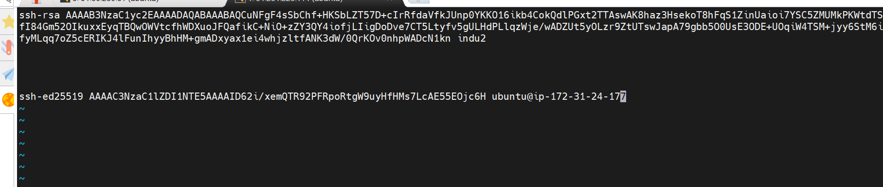

**Step:4(Deploy server)**

*Go to .ssh

*vi authorized keys paste the keys generated in Bulid server.

**Step:5**

*Copying the War file from Build server to Deploy server.

(scp /home/ubuntu/Javawebcal/target/*.war  ubuntu@deploy-public-ip:/home/ubuntu/tomcat/webapps).





